REPORT
“Effective Public Security and Democratic Accountability: Stanford Training Seminar”
A Stanford Training Seminar for Law Enforcement Professionals

The Stanford Program on Poverty and Governance delivered a five-day training course for the Planning Unit of the Mexican Comision Nacional de Seguridad (CNS) from October 11 to 15, 2016. The training was led by Professors Beatriz Magaloni and Alberto Diaz-Cayeros, co-PIs of the State Department-funded research project “Citizen Trust and Evidence-Based Police Accountability and Professionalization in Mexico.”

The week-long discussions and training with key officials and analysts are a key supporting objective (federal component) of our research project, in which we seek to evaluate the police reform process and the effectiveness of coordinated efforts between federal, state and municipal police to contain organized crime, improve police effectiveness and control police corruption. In particular, the discussions included:

- An overview of the situation of firearm deaths and the correlates of this type of violence, with particular reference to Latin America;
- An explanation of the dynamics of violence and police reform in Rio de Janeiro.
- A description of how these processes can be explained by some of the prevailing theories of violence developed by scholarship on civil war and criminal activity.
- Summary of the determinants of police trust in Latin America and a specific discussion of anomie and criminal dynamics in Brazil, Venezuela and Mexico.
- Overview on the Interamerican Human Rights System;
- Discussion of specific case study of the role of CICIG in Guatemala.
- Presentation of a methodology to estimate the value of various drug trade routes using Geographic Information Systems.
- A theoretical discussion of emerging statistical methodologies to address challenges of causal inference and evaluation.
- A technological visit to the Map Room of Stanford Green Library to learn about the use of technologies of geolocation and georectification to produce new datasets from historic documents.
- A field visit to the Stockton Police Department, where the CNS team could get a hands-on experience in learning how a local police department incorporates hotspot policing, operation ceasefire, and other practices in patrolling, dispatching and safeguarding ballistics evidence.
- Lectures from prominent Stanford faculty (Francis Fukuyama, Stephen Stedman, Eric Jensen, Stephen Krasner, Harold Trinkunas, Mirte Postema and Rogelio Perez-Podermo ) about the current debates and scholarship in two expert panels, one on Corruption, Democracy and Rule of Law and one on Emerging Security Issues, Cybersecurity and Counterterrorism.
- Opportunity for CNS analysts to present their own research on the genealogy of organized crime groups in Mexico, an application of risk terrain methodologies to the city of Acapulco, and an analysis of the effects of federal joint operations on homicide rates using synthetic control groups.

In the final session we prepared a timeline of how to best collaborate on the objectives of our project on Citizen Trust. Specifically we agreed that we will coordinate in providing CNS with some of our methodological advances to calculate poverty profiles at the block level, so they can incorporate this disaggregated metric into their work on Risk Terrain in Acapulco; we will develop with them a strategy to analyze how patrolling is carried out in that city, including an analysis of the role of schools as protective and risk factors for youth violence and gang activity; we will start working on focus groups for the federal police participating in joint operations in order to design a questionnaire that will allow us to carry out our survey of the federal police; and we will continue supporting them in understanding why some operativos conjuntos were more successful than others, as well as incorporating other metrics of success different from homicide rates.

The week-long seminar and field activities were instrumental in advancing the following specific goals of our project:

- Develop a diagnosis of the results of joint operations and how those events determined the dynamics of violence among states and municipalities
- Map the socio-economic characteristics using census data and other available information that will allow us to better understand possible correlates and spatial dynamics of violence.
- When available geo-reference gang and criminal activity at the block, electoral district, AGEB or neighborhood level for Tijuana, Mexico City and Monterrey Metropolitan area.
- When possible, map drug trafficking routes.

Following are photos from the seminar and field visits:

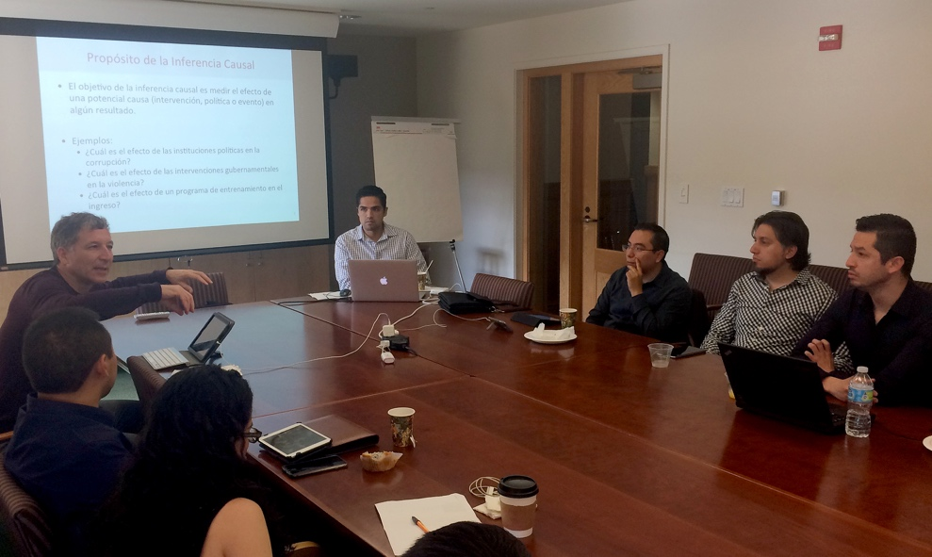

Alberto Diaz Cayeros leads a discussion with the delegation of law
enforcement analysts from Mexico’s Comision de Nacional
Seguridad on topics that range from rule of law to causal inference,
from police reform in the favelas of Rio to U.S.-based approaches
to policing.

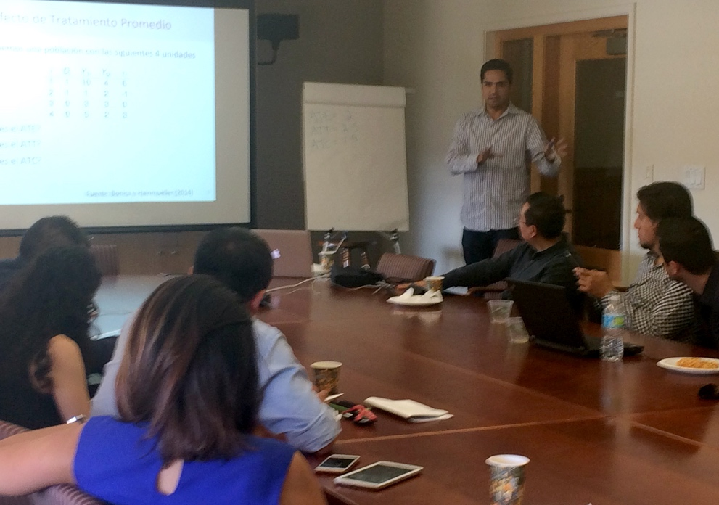

Gustavo Robles, PhD candidate in political science delivers a lecture
on causal inference to the delegation of 12 law enforcement analysts
from the Mexico’s Comision de Nacional Seguridad .

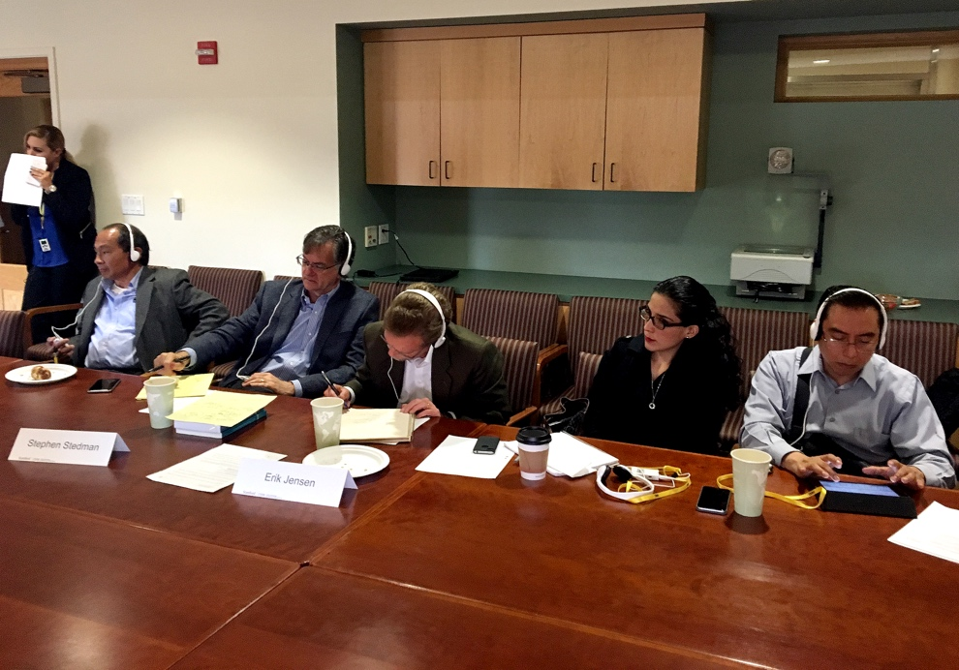
An expert panel from from Stanford’s Center on Democracy,
Development and the Rule of Law that includes Francis Fukuyama,
Stephen Stedman and Erik Jensen shared insights about best practices
in anticorruption, accountability, perception and public trust in
public agencies, civil engagement for accountability purposes,
and role of International organizations.

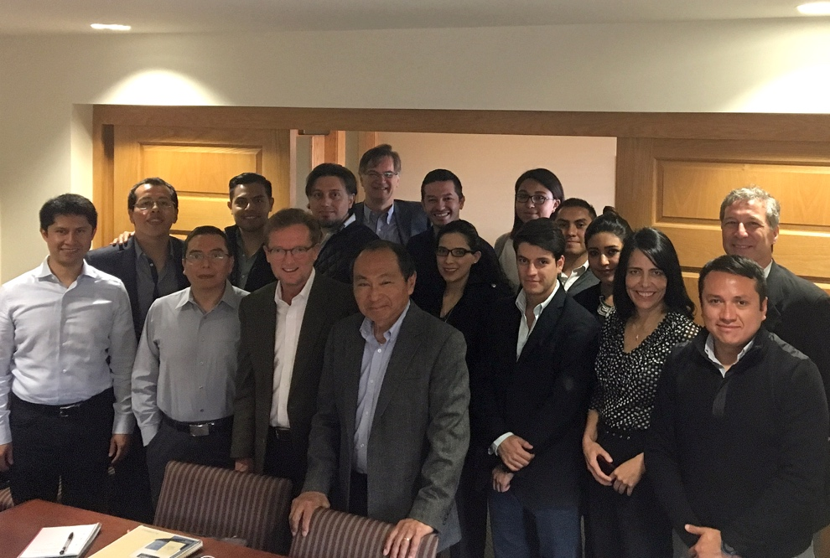
Group shot of CNS delegation with Francis Fukuyama, Erik Jensen,
Beatriz Magaloni and Stephen Stedman.

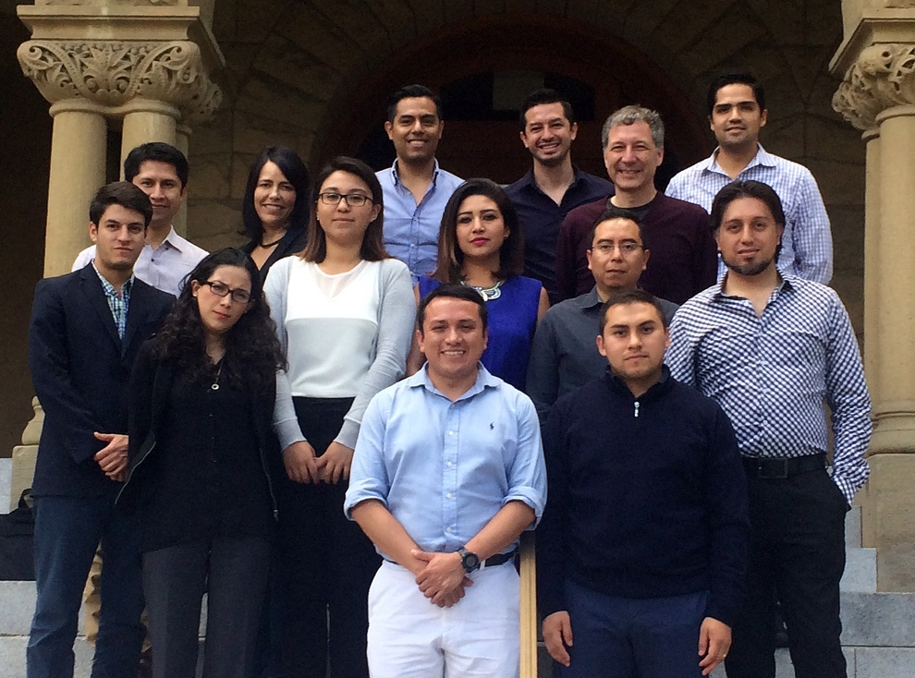
The CNS delegation concludes its seminar with seminar with co-directors
Beatriz Magaloni and Alberto Diaz Cayeros in a group shot outside
historic Encina Hall, home of the Freeman Spogli Institute and the site
of the seminar

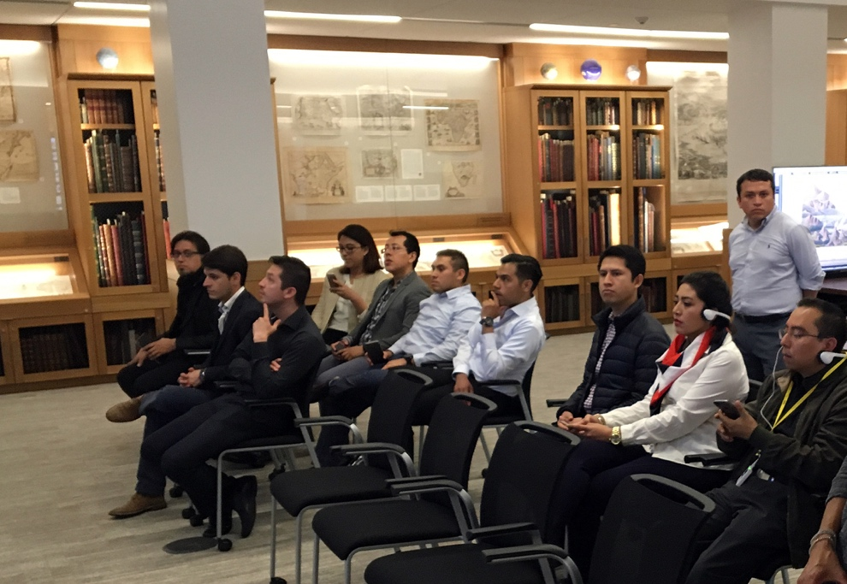
The CNS delegation does a site visit to the David Rumsey Map
Center, an interdisciplinary resource at Stanford University that
enables and promotes scholarship through the use of
cartographic information in all forms—from paper to digital.
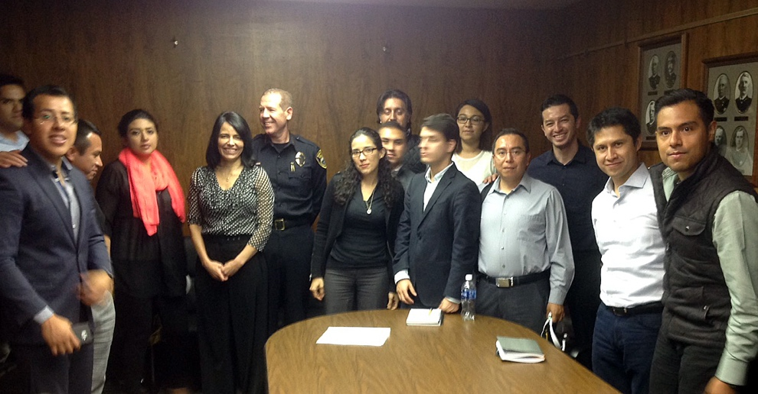
The CNS delegation took a field trip to the Stockton Police Department
to meet Chief of Police Eric Jones, a nationwide advocate of community
policing and body-worn cameras.

